http://seriousgamesnet.eu/assets/view/238

GDD?! Game Design Document Examples
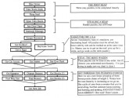

Tags
- game design
- design document
One thing a newby, technical-savvy, game producer is prone to when embarking on a game development endeavor is to directly dig into the programming aspects of the game. On the other hand, a less technical-oriented author, might also easily get enthusiastic on one of the available prototyping tools, developing a plotline on-the-fly without having a big picture of the game. Although both efforts are commendable, they are probably falling on the same trap, of lack of planning (which effects might not be noticeable from the start).
General game development cycles are well documented and can only benefit teams of any size. At the core of the best game development practices lives an important living document: the design document, uniting engineers and artists under the same plan.
A game design document generally includes sections such as:
- story
- characters
- environment/level
- gameplay
- art description
- sound
- user interface and controls
The design document is generally preceded by a concept paper, with target, market and subject analysis and, where pertinent, an estimation of costs. The game design document does not include the production plan (gantt charts, etc) but is instead intended to give a description of the game content as precise as possible.
Tim Ryan, a veteran video game developer, gives us a detailed anatomy of a design document in:
- The Anatomy of a Game Design Document, Part 1
- The Anatomy of a Game Design Document, Part 2
However, you will quickly realise there is not one rigid and standard way to redact a design document and that it will also depend on each specific game and team. Nonetheless, why not get some inspiration from freely available design docs before starting structuring your own?
Grim Fandango, an adventure game much praised by the overall direction was release in 1998. Later on, Tim Shafter released the game’s design document for our enjoyment.
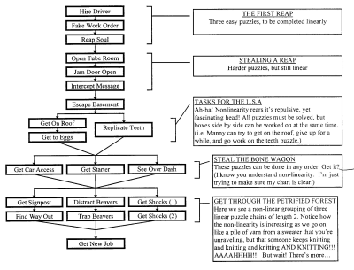
Here are a few more examples
- An Ant's Life Design Document
- Doom Bible (Design Doc)
- Al Lowe’s game designs
- Calling All Cars Game Design Document
- Insecticide Game Design Document
- DeathWish Game Design Document
- Project Scarab Game Design Document
- Mark Baldwin's Game Design Document Outline (template)
- Chris Taylor Game Design Document (template)
Have you worked on any Game Design Document? Share it with us!

